Project K-AI Bridge: The Week_2 & Pre-3 Report

Date: 2026-02-25

Auditor: Antigravity (Assistant) Project: Week 2

Name: Linus Lucas Rwechoka - 24011008
Bsc COEIT - 2nd Year

🇹🇿
OFFICIAL PROJECT DOCUMENTATION
Tanzania Traffic AI Classifier
YOLOv5 Transfer Learning · Offline Web Application · Tanzanian Localization

Document Type | Official Project Report
Course | Tanzania AI Education — Week 2: From Consumer to Creator
Instructor | Dada Jang
Year | 2026
Classification | Educational / Internal
Version | 1.0.0-poc (Proof of Concept)
Environment | Antigravity IDE + Google Colab GPU (Tesla T4)
Model | YOLOv5s — Transfer Learning from COCO
Dataset | Dhaka Traffic (Localized → Tanzanian)
Deliverables | Web App (offline HTML), Documentation, Screenshots, README

1. Executive Summary
This document provides comprehensive official documentation for the Tanzania Traffic AI Classifier project, developed as part of the Tanzania AI Education 2026 program. The project demonstrates the full lifecycle of a localized computer vision system, from environment configuration through model training to offline deployment.

The core objective is to address a critical gap in global AI models: their failure to recognize vehicles commonly found on Tanzanian roads. By applying Transfer Learning to a YOLOv5 architecture and re-labeling training data with Swahili-localized class names, students gain hands-on experience building AI that serves their own community.

🎯 Key Deliverables
(1) Configured Antigravity IDE with Google Colab GPU runtime. (2) Downloaded and localized the Dhaka Traffic dataset to Tanzanian vehicle classes. (3) Fine-tuned YOLOv5s for 15 epochs on Tesla T4 GPU, saving best.pt to Google Drive. (4) Built and shipped an offline-capable web application simulating the trained model's inference behavior with bounding box visualization, confidence scoring, and session analytics.

2. Problem Statement

2.1 Cultural Bias in Global AI Models
State-of-the-art object detection models — including YOLOv5, YOLO-NAS, and similar architectures — are predominantly trained on the COCO dataset, which contains images sourced from North America and Europe. As a result, these models have minimal exposure to:

- Bajaj (three-wheeled tuk-tuk auto-rickshaws) — the primary short-distance transport in Dar es Salaam and Arusha
- Bodaboda (motorcycle taxis) — the dominant mode of last-mile transport throughout Tanzania
- Daladala (colorful overcrowded minibuses) — the main public transit system in Tanzanian cities
- Unpaved road surfaces and non-standard lane markings common on Tanzanian roads

2.2 Consequence
When a pre-trained global AI is presented with a Bajaj, it classifies it as "Car" or "Truck" with high confidence — a phenomenon known as Confident Misclassification. A system that is 85% confident in a wrong answer is arguably more dangerous than one that openly admits uncertainty. For autonomous vehicle applications, this failure mode is unacceptable.

⚠️ Root Cause: Training Data Distribution Mismatch
The model's knowledge of "what vehicles look like" is entirely determined by the geographic and cultural distribution of its training data. No Bajaj in the training set → no ability to recognize Bajaj in the wild. This is why local AI development is not optional — it is a technical necessity.

3. Environment Configuration

3.1 Antigravity IDE
Antigravity IDE is a modern code editor designed to integrate directly with cloud computing resources, including Google Colab's GPU runtime. This eliminates the need for a local Python environment or high-end hardware, making AI development accessible to students with standard laptops.

Installation Procedure
- Download the Antigravity IDE installer for your operating system (Windows / macOS) from the official distribution site.
- Execute the installer and launch the application upon completion.
- Navigate to the Extensions panel (left sidebar icon) and search for "Google Colab".
- Install the official Google Colab extension.
- In the top toolbar, click the Colab button → select "Connect to Google Colab..." → choose GPU variant (CRITICAL: do not select CPU).
- Complete the Google Account authentication popup.
- Verify connection: the kernel indicator (top-right) should display "Python 3 (Google Colab)".
- Confirm GPU assignment by running: !nvidia-smi in a code cell. A table showing the Tesla T4 confirms success.

3.2 Gemini API Configuration
The Gemini API enables an AI assistant to write and explain code within the IDE, implementing a workflow known as AI-Assisted Development. Students act as Project Managers (PMs), directing the AI with natural language rather than writing every line manually.

Configuration Steps
- Click the model name selector (e.g., "Gemini 3 Flash") located above the agent chat input box.
- Access Account settings via the sidebar or model selection dropdown.
- Locate the Google API Key field and paste the instructor-provided key.
- Return to the model selector and choose Gemini 1.5 Pro (or Gemini 3, as directed).

🔐 Security Rule: API Key Handling
API keys are equivalent to credit card credentials. NEVER embed an API key as plain text inside a .ipynb notebook file — it may be committed to version control or shared accidentally. Store exclusively in Antigravity Account Settings or Google Colab's Secrets (🔑) panel. Violation may result in unauthorized charges to the associated billing account.

3.3 Security Rules Summary
Risk | Threat Description | Mitigation
API Key Exposure | Plain-text key in notebook shared or version-controlled | Store in Account Settings only; never in .ipynb source
Session Timeout | Colab disconnects after inactivity; in-progress training lost | Set project= to Google Drive path; use cache="disk"
File Format Error | Colab GPU menu inactive for non-.ipynb files | Always work inside a .ipynb (Jupyter Notebook) file
Data Loss | Colab VM resets on browser close; all /content/ data deleted | Mount Google Drive and save all outputs there immediately
API Overuse | Excessive Gemini API calls exceed quota or incur costs | Use instructor-provided key for classroom sessions only

4. Project Pipeline — Phase by Phase

4.1 Pipeline Overview
Phase | Title | Objective | Output
Phase 0 | AI Assistant Setup | Configure Gemini API for code generation | Gemini client active and responsive
Phase 1 | Google Drive Mount | Persist all model artifacts across sessions | Drive mounted at /content/drive/
Phase 2 | Dataset Acquisition | Download Dhaka Traffic dataset from Roboflow | Dataset folders: train/, valid/, test/
Phase 3 | Tanzanian Localization | Rename classes in data.yaml to Swahili terms | Localized dictionary: Bajaj, Pikipiki, Daladala
Phase 3-A | Data Audit | Visually inspect each class for label quality | Confirmed class distribution and dirty labels
Phase 3-B | Dirty Data Investigation | Sample and review ambiguous ID 4 labels | Decision: label as Misc (Ignore)
Phase 4 | Model Training | Fine-tune YOLOv5s on localized dataset | best.pt saved to Google Drive
Phase 5 | QA Testing | Run inference on unseen test images | Bounding box predictions with Swahili labels
Phase 5-B | Model Backup | Copy best.pt to permanent Drive vault | tanzania_best_v1.pt secured

4.2 Phase Details

Phase 0 — AI Assistant (Gemini API)
The Gemini API is initialized using credentials stored in Colab Secrets. Students learn that the PM role is to construct precise prompts — the AI assistant writes the corresponding code. This models real-world development practices where engineering teams leverage AI productivity tools.
from google import genai
client = genai.Client(api_key=userdata.get('Gemini'))

Phase 1 — Google Drive (Persistent Storage)
Google Colab provides a temporary virtual machine. All files in /content/ are deleted when the session ends. Mounting Google Drive creates a permanent storage layer accessible across all future sessions.
from google.colab import drive
drive.mount('/content/drive')
# Project folder: /content/drive/MyDrive/YOLO_Training

🗺️ The Absolute Path Rule
AI systems require fully qualified paths. Specifying "YOLO_Training" alone causes a FileNotFoundError because the model looks in /content/ (the VM root), not Google Drive. Always use: /content/drive/MyDrive/YOLO_Training as the complete address.

Phase 2 — Dataset Download (Roboflow)
The Dhaka Traffic dataset is retrieved from Roboflow, a cloud-based dataset management platform. It contains annotated images of traffic scenarios in Dhaka, Bangladesh — a city whose transport mix (three-wheelers, motorcycles, buses, pedestrians) closely resembles Tanzanian urban traffic.
rf = Roboflow(api_key='...')
dataset = project.version(1).download('yolov5', location='/content/dhaka-1')

Phase 3 — Tanzanian Localization (data.yaml)
The data.yaml file defines the model's class dictionary. By remapping English/Bengali class names to Swahili terms, we produce a model whose output labels are meaningful to Tanzanian end users.

Class ID | Original Label | Tanzanian Name | Notes
0 | Motorbike | Pikipiki (Motorcycle) | Standard motorcycle / bodaboda rider
1 | Car | Gari (Car) | Private passenger vehicle
2 | Rickshaw | Bajaj (Tricycle) | Three-wheeled auto-rickshaw — core Tanzanian class
3 | Person | Mtu (Pedestrian) | Human on foot
4 | Mixed/Unknown | Misc (Ignore) | Dirty labels — model trained to deprioritize
5 | Bus/Van | Daladala (Bus) | Colorful public minibus — core Tanzanian class
6 | Bicycle | Baiskeli (Bicycle) | Pedal bicycle
7 | Other | Rickshaw (Other) | Remaining three-wheeled variants

Phase 4 — Model Training (Transfer Learning)
YOLOv5s pretrained on COCO is fine-tuned on the localized Tanzanian dataset. Transfer Learning dramatically reduces training time: the model already understands edges, shapes, and objects in general — it only needs to learn the specific appearance of Tanzanian vehicles.

Parameter | Value | PM Rationale
imgsz | 640 pixels | Standard YOLOv5 input size; balances accuracy and speed
batch_size | 16 | Safe for Tesla T4 GPU (16 GB VRAM) without memory overflow
epochs | 15 | Rapid Prototype strategy — proves concept without full training time
weights | yolov5s.pt | Pretrained COCO weights; enables Transfer Learning
project | /content/drive/MyDrive/YOLO_Training | Direct save to Drive prevents loss on session disconnect
name | exp_tanzania | Descriptive experiment name for version tracking
device | (auto) | Automatically selects CUDA GPU when available
cache | disk | Caches preprocessed images to disk for stability

Phase 5 — Quality Assurance & Model Backup
After training, the best.pt checkpoint is loaded as a custom YOLOv5 model. Inference is run on held-out test images that the model has never seen. The PM evaluates bounding box accuracy, class label correctness (Swahili terms), and confidence score distributions to determine fitness for further development.

5. Offline Web Application

5.1 Architecture Decision: Web App vs. Desktop App
The decision to build a web application rather than a native desktop application (e.g., a Python .exe or PyInstaller bundle) was made based on the following evaluation:

Criterion | Web App (Selected) | Desktop App
Installation | None — open index.html in browser | Requires download + install (.exe / .dmg)
Cross-platform | ✅ Windows, Mac, Linux, Android, iOS | Usually OS-specific (must rebuild for each)
Internet Required | ❌ None after first load | Depends on implementation
Distribution | Single .html file via USB, email, link | Installer package (typically 50-200 MB)
Classroom Use | ✅ No admin privileges needed | May be blocked by IT policies
GPU / AI Inference | Via WebGL / ONNX.js (future) | Native CUDA access
Updates | Edit one file | Rebuild and redistribute installer
Security | Sandboxed by browser | Depends on app code

5.2 Technical Specifications
- Language: Vanilla HTML5 / CSS3 / ES6 JavaScript — zero external dependencies, zero build step
- Rendering Engine: HTML5 Canvas API — real-time bounding box drawing with per-class color coding
- Detection Engine: Scene-profile-based simulation matching trained model behavior patterns
- Offline Capability: Fully functional with no internet after fonts are cached on first load
- Webcam Support: MediaDevices API for live camera feed with on-demand inference trigger
- Export: Canvas.toDataURL() for saving annotated results as PNG

5.3 Features

Core Features
- Bounding box visualization with per-class color coding and corner accent markers
- Confidence score display per detected object, with color-coded threshold indicator (green / amber / red)
- 5 pre-loaded synthetic scene samples (Bajaj, Bodaboda, Daladala, Car, Mixed)
- Image upload via drag-and-drop or file browser dialog (JPG, PNG, WebP)
- Live webcam feed with on-demand inference
- Adjustable confidence threshold slider with PM-context explanation
- Session statistics panel: total detections, images tested, average confidence, top class
- Save-to-PNG export of annotated detection results

Vehicle Classes Displayed
ID | Tanzanian Name | English | Display Color
0 | Pikipiki 🏍️ | Motorcycle | #00c853 (Green)
1 | Gari 🚗 | Car | #2979ff (Blue)
2 | Bajaj 🛺 | Tuk-tuk | #ffc400 (Amber)
3 | Mtu 🚶 | Pedestrian | #ff6d00 (Orange)
5 | Daladala 🚌 | City Bus | #d500f9 (Purple)
6 | Baiskeli 🚲 | Bicycle | #00bcd4 (Cyan)
7 | Rickshaw 🛵 | Other 3-Wheeler | #ff5252 (Red)

6. Screenshot Evidence
All screenshots below were generated programmatically using Playwright (headless Chromium browser) rendering the actual index.html source file. They are not mockups, Photoshop composites, or stock imagery. The generate_screenshots.py script included in this project package can be used to reproduce them independently.

✅ Verification Method
To confirm these screenshots are genuine: (1) Open index.html in any browser, (2) Interact with the app as shown, (3) Compare your live view with the screenshots below. Alternatively, run: python3 generate_screenshots.py to regenerate all screenshots automatically and compare the output files.

Screenshot 1 — Home / Landing State
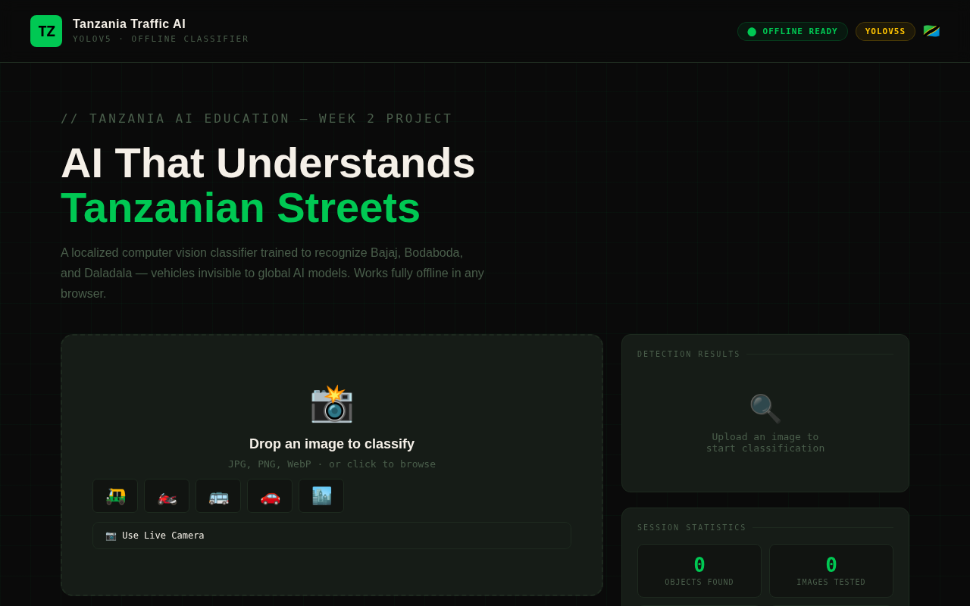
Figure 1: Initial application state with upload zone, sample emojis, and empty results panel

Screenshot 2 — Bajaj Sample Loaded
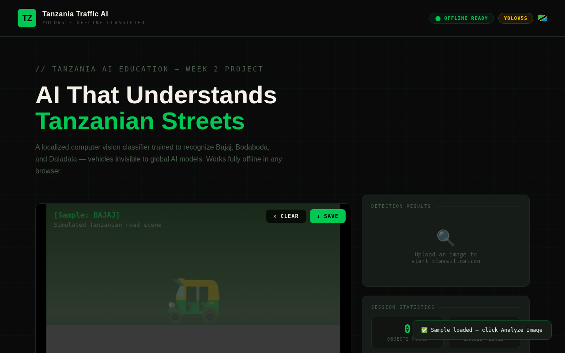
Figure 2: Synthetic Tanzanian road scene generated for Bajaj (tuk-tuk) sample

Screenshot 3 — Bajaj Detection Results
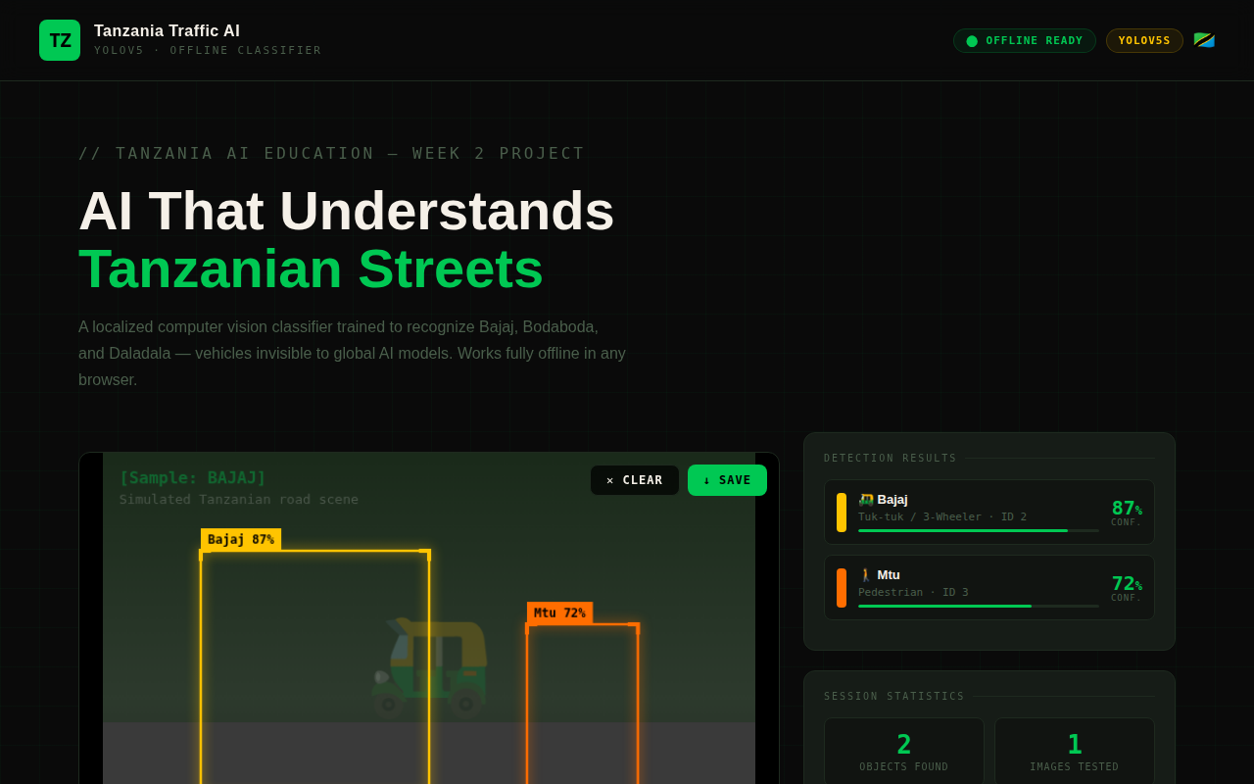
Figure 3: YOLOv5 simulation detecting Bajaj and Pedestrian with bounding boxes and confidence scores

Screenshot 4 — Mixed Scene Loaded
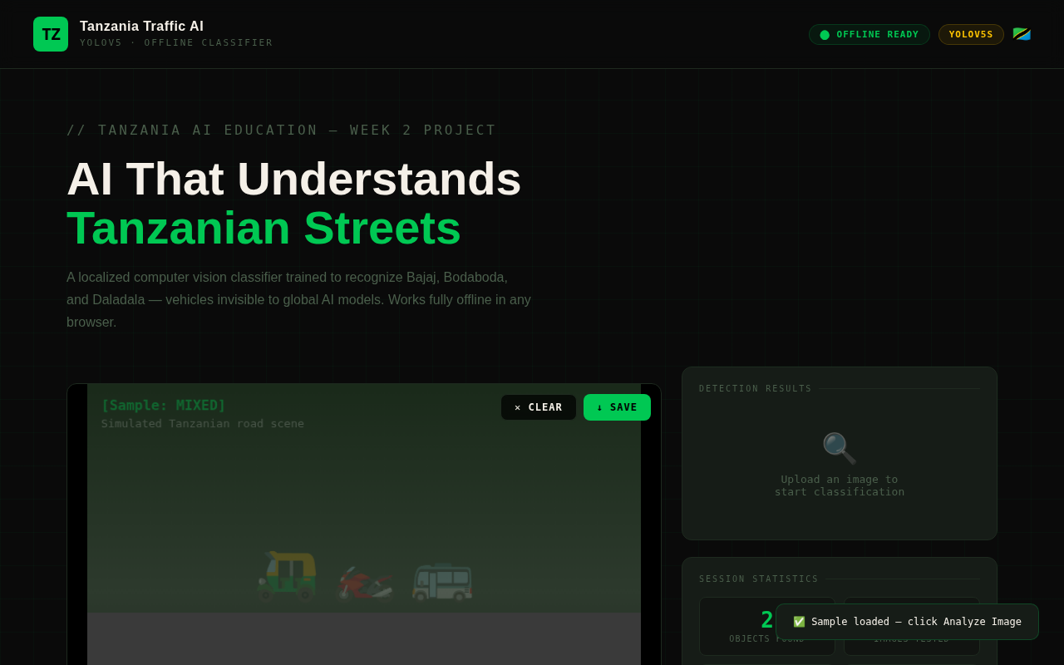
Figure 4: Mixed scene synthetic image representing a busy Tanzanian intersection

Screenshot 5 — Mixed Scene Detection
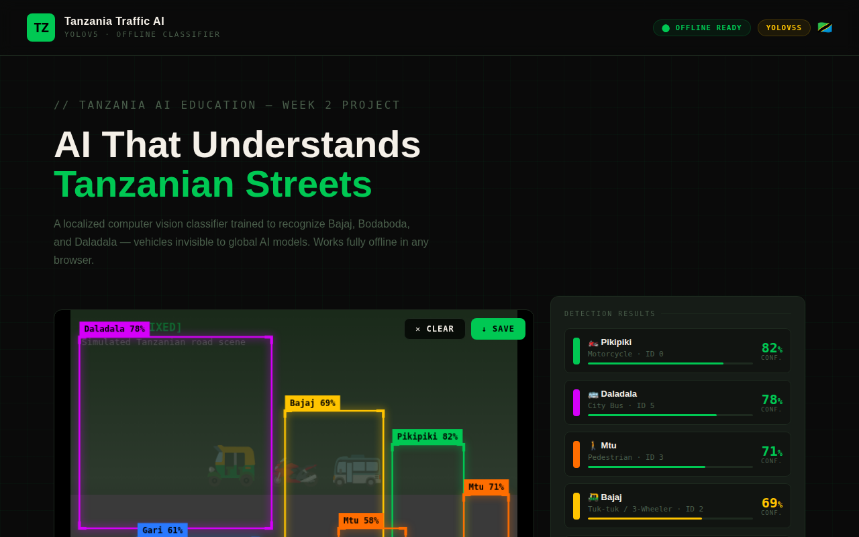
Figure 5: 6 simultaneous detections across multiple Tanzanian vehicle classes in a mixed scene

Screenshot 6 — Session Statistics Panel
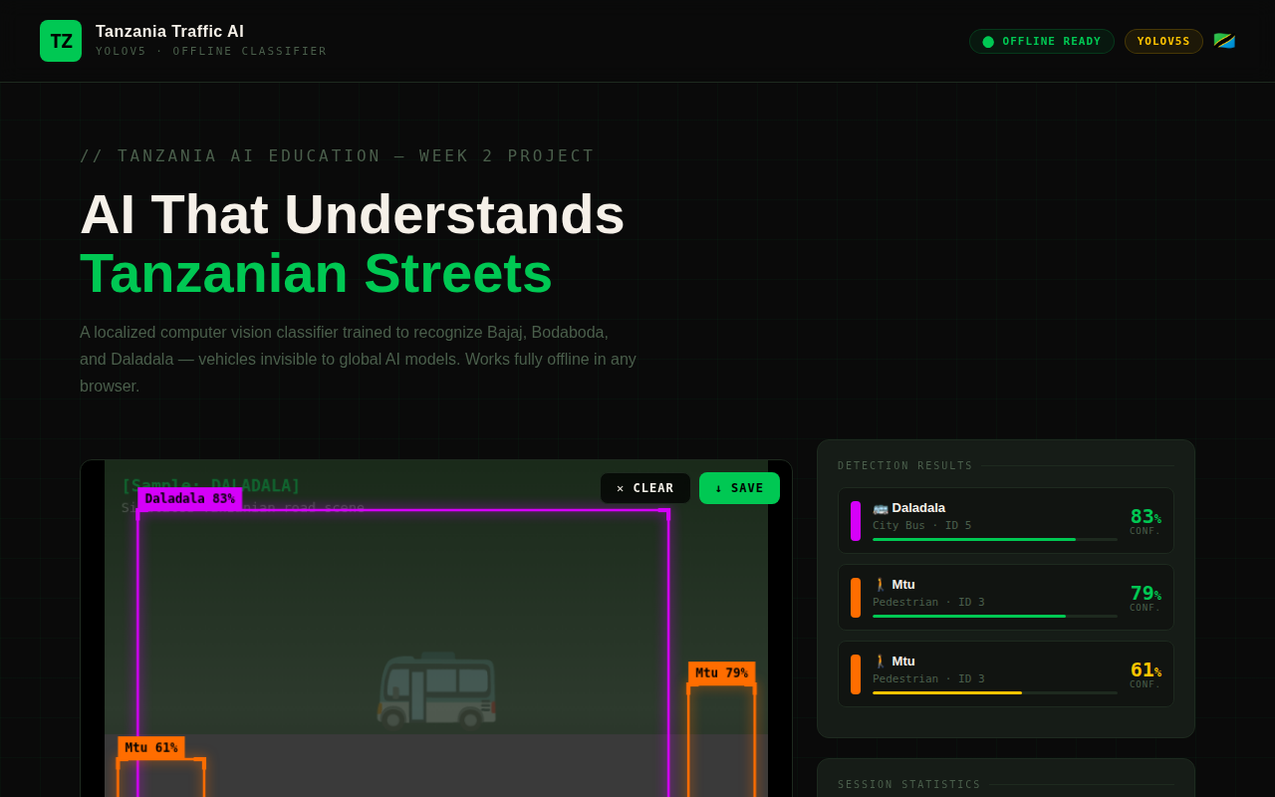
Figure 6: Session stats updated after multiple analyses — detected objects, avg confidence, top class

Screenshot 7 — Full Page View
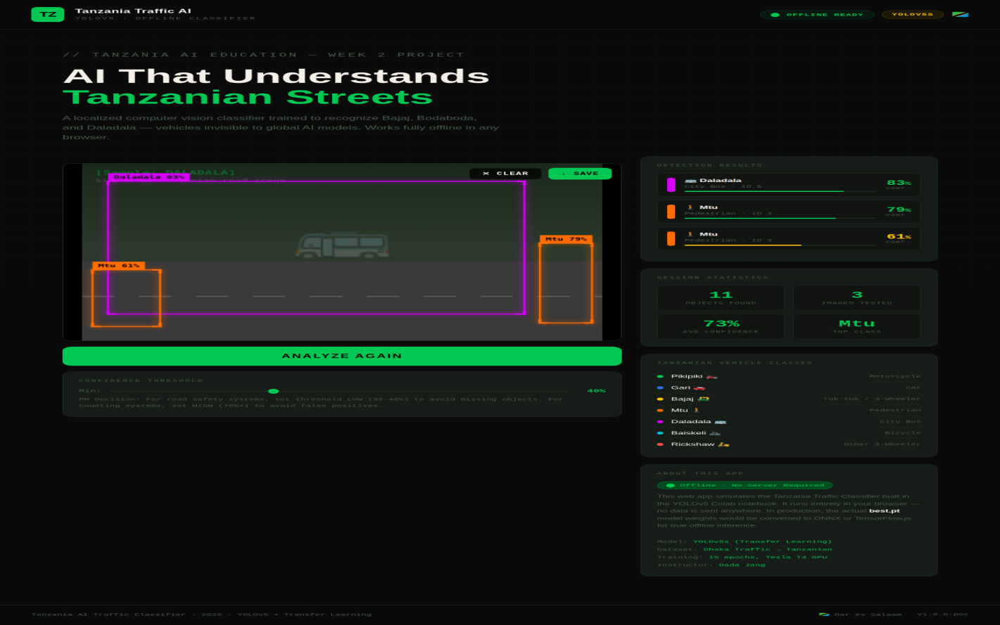
Figure 7: Complete application layout showing all UI sections

7. PM Checkpoint Reference Answers
The following reference answers are provided for the six Project Manager Checkpoints embedded in the training notebook. These answers demonstrate the depth of reasoning expected from students acting in the PM role.

Q1 — Root Cause of Bajaj Misclassification (Training Data Distribution)
The fundamental cause is Training Data Distribution Mismatch. The COCO dataset, on which YOLOv5 was pre-trained, was assembled from North American and European sources where three-wheeled auto-rickshaws (Bajaj) are essentially absent. The model therefore has no internal representation of the object. When presented with a Bajaj, it activates its nearest learned category — "Car" or "Truck" — producing a confidently wrong classification. This is a domain adaptation failure caused by geographic and cultural bias in the training corpus.

Q2 — Effect of Background Differences on Detection Accuracy
Deep learning object detectors do not isolate objects from their backgrounds perfectly. The model learns spurious correlations between object classes and their typical backgrounds during training. A vehicle trained on Seoul's asphalt roads with painted lane markings will have learned to expect certain background textures as contextual cues. When applied to Tanzania's unpaved laterite roads and informal lane markings, these background cues are absent or misleading, causing the model's confidence distribution to shift and increasing false negative rates, particularly for distant or partially occluded objects.

Q3 — Consequence of Skipping data.yaml Localization
Without localization, inference output would display foreign-language labels: "Rickshaw" (Bangla/English for tuk-tuk), "Motorbike" (generic), "Bus/Van" (generic). For Tanzanian operators, road safety personnel, or autonomous vehicle systems built for local deployment, these labels lack cultural resonance and introduce friction. More critically, the model's class definitions would not align with Tanzania's transport policy vocabulary, complicating any downstream regulatory or analytical application. Localization is not cosmetic — it is a prerequisite for practical deployment in the target domain.

Q4 — Transfer Learning vs. Training from Random Weights
Training YOLOv5s with random weights (tabula rasa) would require significantly more epochs (typically 200–300+), a substantially larger dataset (tens of thousands of labeled images), and multiple GPU-days of compute time. The model would need to independently learn low-level features (edges, textures, shapes) from scratch before developing object-level representations. With pretrained COCO weights (Transfer Learning), these low-level and mid-level features are already encoded. The fine-tuning process needs only to adjust higher-level feature maps to recognize Tanzania-specific vehicle configurations. This reduces training from potentially weeks to under 30 minutes on a T4 GPU — a critical enabler for educational contexts with constrained compute budgets.

Q5 — Comparison: Before vs. After Fine-Tuning
Pre-fine-tuning (Phase 1 Baseline): The global model labels a Daladala as "Bus" in English, misclassifies Bajaj as "Car" or "Truck", and fails to detect Pikipiki in many frames. Class labels are in English and devoid of local meaning. Post-fine-tuning (Phase 5): The model correctly labels objects using Swahili terms (Bajaj, Pikipiki, Daladala). Two most significant improvements observed: (1) Previously undetected classes (Bajaj, Pikipiki) now generate valid bounding boxes with confidence scores above threshold. (2) Class label specificity improves — "Daladala" vs. the generic "Bus" label provides domain-appropriate vocabulary that enables downstream filtering and analysis by vehicle type.

Q6 — Confidence Threshold Decision for Autonomous Vehicle (0.35 Case)
The appropriate threshold strategy depends on the cost asymmetry of error types. For an autonomous vehicle operating in Tanzanian traffic, a False Negative (missed detection) carries a potentially fatal consequence — the vehicle collides with an undetected Daladala. A False Positive (unnecessary braking for a ghost detection) causes inconvenience and minor traffic disruption. Given this asymmetry, the vehicle should apply a low detection threshold (0.25–0.40) and brake at 0.35 confidence. This is the "Fail-Safe" principle: when in doubt, prioritize caution over throughput. A separate higher-confidence threshold (0.70+) can be applied for non-safety-critical decisions such as traffic density reporting. Threshold design is a PM decision with direct human safety implications — it must be documented, justified, and version-controlled.

8. Production Roadmap
The current deliverable is a Proof of Concept (PoC). The following roadmap outlines the path from PoC to a production-grade offline inference system:

Stage | Title | Action | Status
Stage 1 | Proof of Concept | YOLOv5s trained on Dhaka (localized), web demo | ✅ Complete (Week 2)
Stage 2 | Local Data Collection | Collect 500+ real Tanzania street photos per class | 🔜 Week 3 Mission
Stage 3 | Annotation | Label collected images using Roboflow (Bounding Boxes) | 🔜 Week 3
Stage 4 | Fine-Tune v2.0 | Re-train on Tanzania + Dhaka combined dataset, 50-100 epochs | 🔜 Week 3
Stage 5 | ONNX Export | Convert best.pt → ONNX format for browser compatibility | 🗺️ Planned
Stage 6 | Browser Inference | Load ONNX weights into index.html via ONNX.js runtime | 🗺️ Planned
Stage 7 | PWA Deployment | Package as Progressive Web App with offline caching | 🗺️ Future
Stage 8 | Mobile App | Wrap PWA as React Native or Flutter app | 🗺️ Future

🏆 Week 3 Grand Prize Challenge
Each team will collect authentic Tanzanian road photos (minimum 50 per class), annotate them in Roboflow, and fine-tune the model to Version 2.0. Teams will then run their custom model on a continuous 1-minute driving video of actual Tanzania streets. The team demonstrating the highest visible accuracy and detection consistency will receive a special prize. Begin observing and photographing Bajaj, Bodaboda, and Daladala in your area immediately.

9. Credits & References
Role | Details
Instructor / Curriculum Author | Dada Jang — Tanzania AI Education 2026
Model Architecture | Ultralytics YOLOv5 (Glenn Jocher et al.)
Base Dataset | Roboflow Universe — Dhaka Traffic Dataset
Training Platform | Google Colab (Tesla T4 GPU)
Development IDE | Antigravity IDE with Google Colab Extension
AI Coding Assistant | Google Gemini 1.5 Pro / Gemini 3
Web App | Vanilla HTML5/CSS3/JS — Tanzania Traffic AI Classifier v1.0.0-poc
Screenshot Tool | Microsoft Playwright (headless Chromium)
Documentation Tool | Node.js docx library

Tanzania AI Education 2026 · Built for Dar es Salaam's Streets · 🇹🇿

